Phonekeeper User's Manual

Lutong Technology, Office Work Optimization
Lutong Bochuang Technology & Trade (Beijing) Co., Ltd
http://www.lutongrj.com

Dear Users:
Hello!
Thanks for using products from Lutong Bochuang Technology & Trade Co., Ltd (hereinafter referred to as Lutong Company or Lutong Technology). Before using the product, Lutong Company suggests you read this users' manual first to understand the installation and the related use knowledge of software system (Phonekeeper) of Lutong series so that you can better use our product and improve your work efficiency.
Established in 2003, Lutong Technology is located in Zhongguancun, Beijing, China. It has developed into a high-tech enterprise integrating hardware R& D and production as well as software development after being repeatedly rectified and merged. With professional software and hardware technician, the company covers various aspects, such as, software development and singlechip design. The company, which has achieved multiple hardware patents and software copyrights, has independent software and hardware design capacity. Besides, Lutong Technology is able to provide you with perfect service, first-class technology and comprehensive solutions.
In our service field, our specialization, technical service, project quality and advanced service philosophy have been fully recognized by customers, which enable us to maintain long-term and friendly partnerships with customers. Meanwhile, we keep good partnerships with many IT companies, which can help us to gain more perfect support from all aspects so as to provide better service for customers.
Lutong Technology has newly launched office software of Phonekeeper series with independent intellectual property right, including computer recording system, phone recording system, phone CRM system (standalone version and network version), mass-fax system, phone voice multicast system, phone number detecting system, phone call center system, and phone voice navigation system, as well as the phone CRM system, mass-message system, webpage refreshing, filling and voting system for industries such as water delivering, flower delivering, liquefied gas delivering, flight ticket sales, travel agency and hotel. Besides hardware development and software customization, our company provides the second development for hardware such as phone recording and caller ID as well as offers the development examples, development documentations and necessary technical support!
In the process of using Lutong products, please contact us at any time for the purpose of upgrading your products in time and obtaining the latest product information. In the meantime, for supplying better service, Lutong Company welcomes any comment and suggestion on our products and services from you.
Any means below are available for getting in tough with our company:
Add：No. 8, South Building 2, No. 85, Beiwa Road, Haidian District, Beijing City
Zip Code :：100036
Mobile: 13141122573，13051403769
Msn : lutongrj@hotmail.com
Email:13051403769@qq.com,wangtleiycp@163.com
Q Q : 718473996、773834194
Website: http://www.lutongrj.com
Software Introduction
Why this system should be used?
1. Phone recording can improve the enterprise's phone management system
2. Recording every incoming call can lay a foundation for future business follow-up.
3. The phone conversations can be repeatedly heard at any time when the phone orders are many.
4. The real-time recording is helpful for witnessing your telephone service .
5. It can be used as legal evidence when business disputes occur.
6. It is applicable to observing the utilization ratio of enterprise phone and human resource.
7. It is able to seize business chance that might be missed when the line is busy.
8. It can be adopted to collectively analyze the psychology of key clients who participate in telephone negotiations so as to jointly formulate business strategies.
9. It can be used for overall observing the staff's working ability, vocational level, and telephone etiquette and norms.
10. It can help to find and stop the behavior of ruining corporate benefit in shortest time.
11. It can reduce the telephone rate of the company and investigate the phone conversation for phone bill with large amount.
12. It can keep the call records for a long term so that the customers will not be lost due to the staff demission
Based on the requirements from industries of telecommunication, electric power, securities and so on, and through combining their application features, our company has independently researched and developed Phonekeeper, a full digital recording system. It can achieve the functions, such as, non-interfering recording for multi-channel telephone lines, real-time monitoring, inquiry, and recording playback, as well as realize the effective management of recording documents, and automatic back-up and deletion of documents. It is widely used in the fields of futures brokerage firm, public security, electric power, security, paging centers, each dispatch system and so on. The system supports recording for minimum 1 line and simultaneous recording for maximum 128 lines, monitors the phone coversation of any line in real time in the machine of recording system, and inquiries the recording at any time in the machine of recording system according to the calling and called numbers, date, time period, channel number and so on.
Basic functions:
System support: Phonekeeper supports operating systems such as Windows xp, 2000(professional edition and server edition), 2003(professional edition and server edition), vista and WIN7.
System interface: Phonekeeper adopts new high speed USB interface and PCI interface.
Multichannel recording: stand-alone can simultaneously record the phone conversations from 1 telephone line to 128 telephone lines. Each channel respectively save its documents without interfering with each other or impacting normal phone conversation of both sides.
Ways of recording: voltage control recording (off-hook to record the whole conversation between two parties), keying recording (press the * key and # key of telephone), voice activated recording (start recording when speaking).
Direction judgment: the system shows extremely powerful judgment function, which can fully recognize incoming call and outgoing call.
Recording time period: users are allowed to freely set the starting time of recording according to the working environment for the purpose of saving the hard disc space calling and called: with DTMF/FSK incoming call system, the incoming and outgoing call numbers can be automatically identified.
Calling region: this system can automatically identify the region of all incoming and outgoing calls.
Real-time monitoring: local area network can freely monitor the phone conversation of any line, which will cause no influence on phone conversation quality or on the normal recording.
Real-time display: the screen displays the working state, disc status, and system time of all telephone lines in real time.
Local playback: playback can be carried out with active speaker or earphone in the locality. In addition, recording and playback can be conducted at the same time and the backup voice records can be played as well.
Records inquiry: the system can fuzzily search the voice records according to the date, recording time, channel number, local number, calling and called numbers, etc.
Records play: the system has the functions of play, stop, pause, fast-forward, fast-backward, automatically displaying play time, etc.
Records back-up: this system supports automatic back-up and manual back-up. It can backup the records to other hard discs.
Records deletion: the system has the manual deletion as well as automatic deletion and overlay function; when the space is filled up, the system will delete the record files at the earliest.
Records format: all recording files adopt WAV format, which supports all current windows players.
File format: it can automatically identify incoming and outgoing call numbers, call date, starting time, stop time, duration of call, incoming and outgoing calls, channel number, etc.
Storage patterns: the computer files can be generated automatically to save the recording files based on each year, each month, each day, and each channel.
Voice compression: the compression rate is high. It supports compression ways, such as, A-law, Wav and GSM. 160 G hard disc can hold recording files of 28,000 hours.
Auto gain control: the recording system shows the function of auto gain control, which can automatically adjust the volume of both sides on the phone so that the voice will not be too low.
Hard disc management: this recording system supports more than 6 disc storages (partitioning hard disc, network hard disc, etc)
Access control: the recording system has multiple access controls.
Card management: with screen popup function, it can record the customers' incoming call information for convenient communication next time.
Records management: with powerful records management function, it can list, print, sum up and group the incoming and outgoing calls.
Statistics management: this system can make statistics on the number of incoming and outgoing calls, missed calls, duration of call and so on for each channel every day.
Alarm function: when the system appears to be abnormal or the hard disc space is insufficient, the system will give an alarm by voice prompt or screen prompt so that the administrator can handle it in the shortest time.
Lines support: this system can record the analog lines drawn from outside line, extension line, digital line, VOIP line, ISDN line, etc.
Data base: the system is convenient for the customers to manage data base
Log administration: the system has complete operation logs, which can record each operation on the system.
Website opening: the specified website can be set to open automatically after the incoming call.
Email back-up: after being recorded, the files can be automatically sent to specified email.
Ftp back-up: the files can be automatically sent to the specified FTP after being recorded.
Customer management: the customer management program is powerful with functions of multi-level grouping, adding new cards, and modifying cards.
Screen popup: the incoming call number and customer's information can automatically pop up. And the customer's information can be typed in at the bottom of the popup interface.
Cards import: it can import and export customer's information.
Popup screen modification: the title of the popup screen can be modified.
Information print: the incoming call details can be printed.
Digital recording: digital recording and playback can make the original hi-fi sound reappear. The hard disc with high-capacity is adopted to save recording files, which is reliable and safe. Besides, the files can be read quickly and conveniently.
Stand-alone system supports simultaneous recording for maximum 128 analog telephone lines.
Recording retrieval: the complicated call records are quickly retrievable. And the recording can be retrieved according to channel number, call date, call time, calling and called numbers, etc.
Intuitive interface: the interface show the state of on and off hook as well as the text prompts for the calls of each channel, which is intuitive, and can be learned and used easily.
Phone conversation monitoring: phone conversation line can be monitored in real time.
Parallel operation: recording as well as retrieval and playback of call records can be simultaneously implemented.
The recording files format of Phonekeeper:
Wave: namely, Microsoft wave
Applied range
Recording for disciplinary inspection & supervision: to let you understand all when listening to the recording
Recording for electric power, railway and civil aviation dispatching systems: to make the responsibility clear.
Office work recording of government and enterprise leaders: to record the tasks assigned by the supervisors and assign the work to the subordinates.
Telephone interviews of law and news media, and evidence obtaining: nothing will be missed.
Disciplinary Inspection & Supervision Office, Public Security Organs, People's Armed Police, and People's Court: to protect the people's interest.
Recording for financial securities as well as trade and business: for fair trading
Unattended recording for major projects: to deliver information in time.
Recording for complaints and report: to uphold justice.
Recording for customer service: to make sure no customer resources are lost
Family recording to save the family love recording

Phonekeeper can be applied to:
Phone recording of disciplinary inspection & supervision, tax bureau phone recording, education phone recording, bank phone recording, leaders phone recording, secretary phone recording, lawyer phone recording, entertainment phone recording, hotel phone recording, shopping mall phone recording, estate phone recording, training phone recording, family love phone recording, recording of public security system, phone recording of avoiding harassment, finance phone recording, security phone recording, medical phone recording, trade phone recording, railway phone recording, travel phone recording, interview phone recording, phone recording of electric power industry, phone recording of armed police, judicatory phone recording............
Software Licensing
1. Office software system of phonekeeper series (Phonekeeper) has independent intellectual property right. All rights are reserved by the developer: Lutong Bochuang Technology & Trade (Beijing) Co., Ltd.
2. Lutong Bochuang has the right to change the BUG in the system without notice, which shall not be liable for any result there from .
3. This system is designed for improving our daily office work efficiency. Please note that if you go against the local laws or regulations or not when you use it for other purposes. We shall not assume the responsibility for legal problems generated during the software use process.
4. We specially remind you not to forget backup the recording files and customers' information when you reinstall and delete the files. We shall not take the responsibility for lost data due to your operation on computer system.
5. Please respect the intellectual property law. Altering this system by disassembling, reverse engineering and other approaches in any form and using the altered phonekeeper are prohibited, which shall be sanctioned by law. We have used multiple measures to protect the software, who shall not take the responsibility for the results arising from the process of altering our software.
6. Lutong Bochuang reserves the right to final interpretation of this agreement and has the right to change the office software of phonekeeper series without notice.
7. Lutong Bochuang will keep improving the software products and updating the products regularly to satisfy more customers' needs. Please inquire the software upgrades by yourself for our company will not inform you of this.
8. If you install or use office software system of phonekeeper series, it indicates that you agree with this agreement. If you don’t agree with this agreement, please don't copy, install, test, use and sell this software.
Software registration
The software of this version, which is not bound to the computer, is given away for free when purchasing hardware. It can be used without registration or limitation.
Important Support Information

For Remote Internet Support please download Teamviewer Quick Support below and supply your technician with your ID and password once the small program has been installed.

http://www.lutongrj.com/Uploadsoft/TeamViewerQS.exe




Please download soft and Users manual below-:

http://www.lutongrj.com/Uploadsoft/PhoneKeeper.rar
Catalogue
Preface 4
Computer system and installation requirements 5
1. Instructions 5
2. The requirements for computer system 5
3. Telephone line connecting method 5
a) Two cores analog telephone line 5
b) Analog digital signal line 5
c) Digital line 6
d) The phonekeeper adapter 8
Installation instructions for Software 10
1. Caution 10
2. Installation instructions for LT-P 04/ 08/ 16 10
3. Installation instructions for LT-U 01/ 02/ 04/ 08/ 16 11
4. Installation instructions for LT-101/102(old) 12
5. Name of the software 13
Software Language and network setting 13
1. Modify the Language text 13
Operating instructions of service software 13
1. Recording System startup 13
2. User logon 14
3. Recording documents searching 15
A. Date and Channel ID. 16
B. Screen calls on 16
C. Customer info (support fuzzy query) 16
D. Call duration 17
E. Recording file playing 17
F. Backup recording history 17
G. Delete recording history files 18
H. History list to excel file 19
I. Print out details 19
J. Add note 20
K. Auto play 20
4. Real time monitoring 20
5. 【Statistics】 21
A. 【Statistic analyze】 22
B. 【Statistic Print】 22
6. System setting 22
A. Record Hard Disk 23
B. User Setting 23
C. Popup 25
D. Record Backup 27
E. Email Backup 28
F. FTP Backup 29
G. Other parameters 30
H. Switch 31
7. Channel Setting 33
8. Customer 34
A. Add/Edit/Delete/Empty Group 35
B. Add/Edit/Delete Card 37
C. SearchCard 38
Operating instructions of Screen Popup 38
1. Screen Popup Interface 38
2. ⒁Incoming call ToWordXp 39
3. ⒂Incoming call print 40
4. ⒃Modification of Popup Interface 41
5. ⒄Modification of Drop-down List 41
Database Import & Export 42
1. Import of Excel Data 42
2. Export of Excel Data 43
3. Export & Import of Other Data 44
4. Database Maintenance 44
Problem solution 45
Technical Parameters 46
Contact us 47

Preface
Welcome to use our 3rd generation recording system. The system is designed for recording analogy signal of telephone. Our company owns intellectual property rights of both hardware and software. For almost 10 years’ selling, the recording systems have stable quality, strong function. The systems are widely applied in: police station, stock market, bank, air line company, railway and electronic manage department, marketing division of company and factories.

The user manual shows installation steps of all hardware and software. And take instances of USB 8 Port recording box(LT-U08), demonstrate correct steps under Windows XP operation system. Use of all products can refer to LT-U08. Recording products of our company have USB series and PCI port series. USB recording systems are recording box. PCI recording systems are recording cards. All models can be simply divided into USB and PCI version:
USB models are: LT-U01, LT-U02, LT-U04, LT-U08, LT-U16;
PCI models are: LT-P04, LT-P08, LT-P16.

There is only one software for recording products, The software are use GSM for compression, have 5 times compression ratio, 1G space can contain 175 hours recording files. The recording files are “.WAV”. Operation of the software is demonstrated in the user manual.
The matched hardware for phonekeeper comprises USB recording box of 1-16 lines and PCI recording card of 4-16 lines. For recording box and recording card, multiple hardware can be used through overlaying.
Caution: all USB and PCI models use same software.
" How many lines " means "how many telephones" can be simultaneously recorded (including incoming and outgoing calls), and if they are connected to the front of telephone switch, it means the lines of "how many phone numbers" can be recorded, while if they are connected to the back of telephone switch, it indicates "how many extension telephones" can be recorded.

Computer system and installation requirements

Instructions
- Operation system should be installed within windows systems.
- Suppose the recorder software is installed on “D：/PCI816/ Server08”；the CD-ROM is disk “F”
- Each PC can run 8 pieces of LT-U01, LT-U02, LT-U04, LT-U08, LT-U16, LT-P04, LT-P08, LT-P16 at same time.

The requirements for computer system
- Hardware：CPU：no less than C800 or about C800；
Memory：no less than 128M ;
Hard disk: above 20G
Operating System: LT-U01, LT-U02, LT-U04, LT-U08, LT-U16, LT-P04, LT-P08, LT-P16 support WIN98/WIN2000 /WIN XP/WIN2003/Vista/WIN7(32bits and 64bits).

Telephone line connecting method
- Two cores analog telephone line :
Two cores analog telephone line is most widely used. It’s used for the most common analog telephone. The connecting method is as shown in fig1-3-1
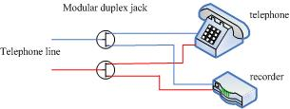
1-3-1
- Analog digital signal line:
The analog digital line is used by analog digital telephone, it contains 4 lines. The two middle lines are used for signal transmitting. So, we use the two line for recording. Recorder and the two middle analog digital lines should be parallel connection as figure 1-3-2. But there still some exceptions of line arrangement. Please inquire the telephone company for details.
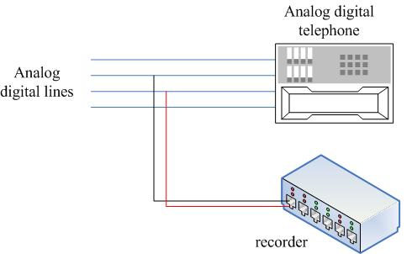
1-3-2
- Digital line:
Digital telephone and network telephone have the digital line. They can not record directly, you can record them by our other adapter LT-88.
the LT-88 adapter:
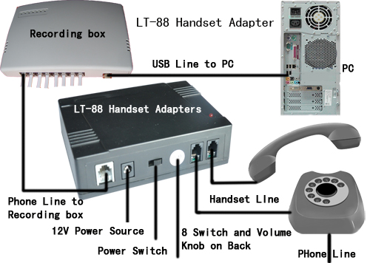
You also can connect line as below.
Microphone and earphone of telephone, they all have 2 lines, positive polarity and GND. There are two kind of situation about digital line.
Situation one: for the condition that GND of microphone, earphone, and PC are the same ground line. Connecting method of this situation shown as 1-3-3(1), use two positive polarity lines for recording. It’s good to use connection method as figure 1-3-3(1). But it has a pre-condition: Power supply GND has to ground. And Different digital telephone has different arrangement of line sequence of microphone and earphone lines. Here the only method for finding positive is traverse. Suppose we can see 1&2 lines are for microphone and 3&4 lines are for earphone. Connect 1st line and 3rd line to one RJ11. Then plug the RJ11 into recorder. Select 【Audio control】on software interface to see, if the recorder can work or not. If it works, the line is correct. If not, please go back to connect 1st & 4th or 2ed&3rd or 2ed&4th lines to RJ11 then try again. : select the 【Audio control】 model,(please refers to chapter 4-7-2) use the positive polarity lines of microphone and earphone for making RJ11. then connecting to recorder.
Situation two: is that the GND lines of microphone earphone and PC are different. The connecting method is shown as 1-3-3(2). Positive lines of microphone and earphone connect to an RJ11. GND lines of microphone and earphone connect to another RJ11. these two RJ11 connect to two channels of recorder. So, the signal of caller and speaker are in two channels.
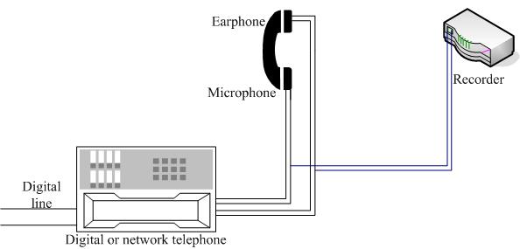
1-3-3(1)
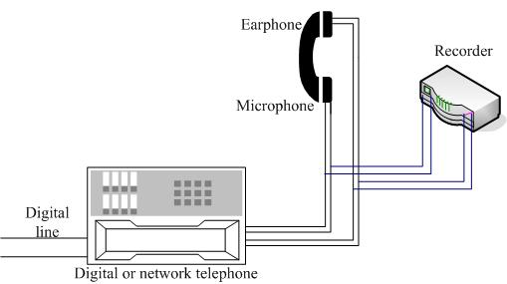
1-3-3(2)
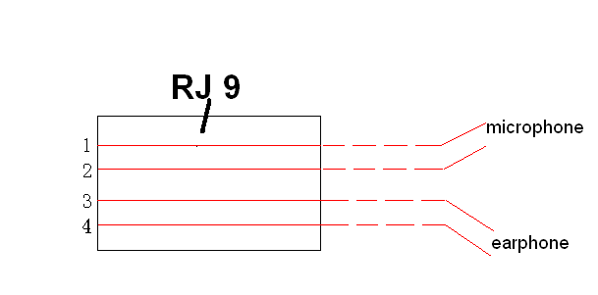
1-3-3(3)
- The phonekeeper adapter:
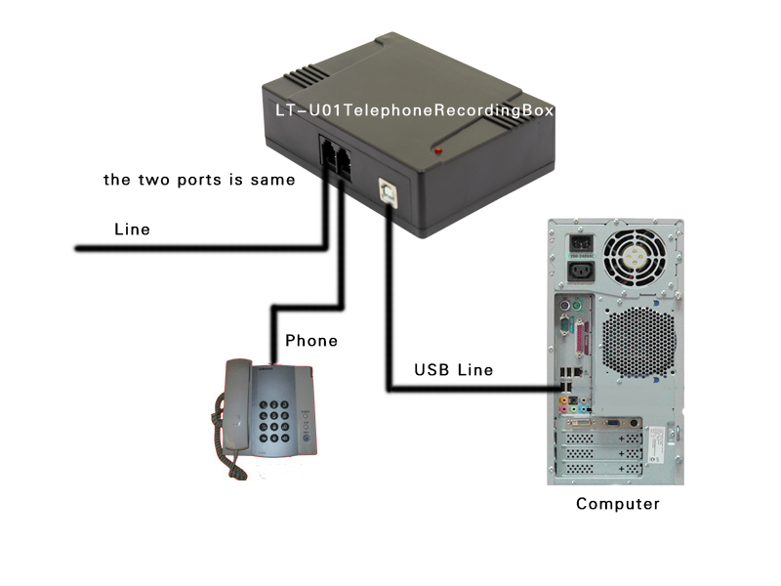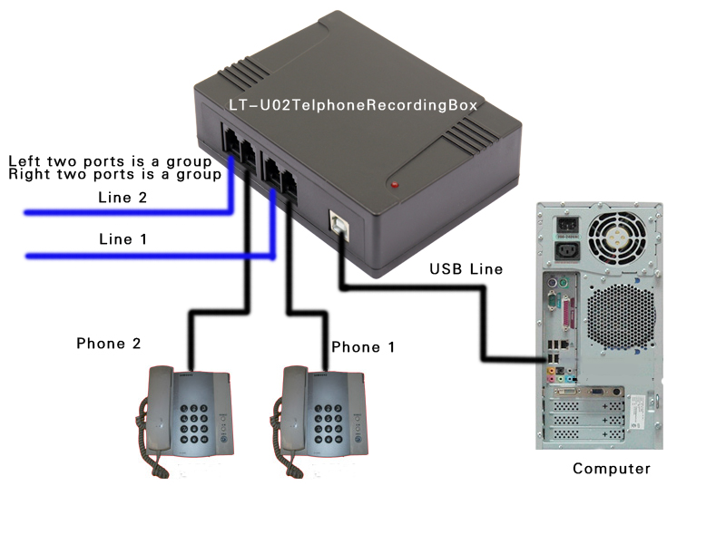
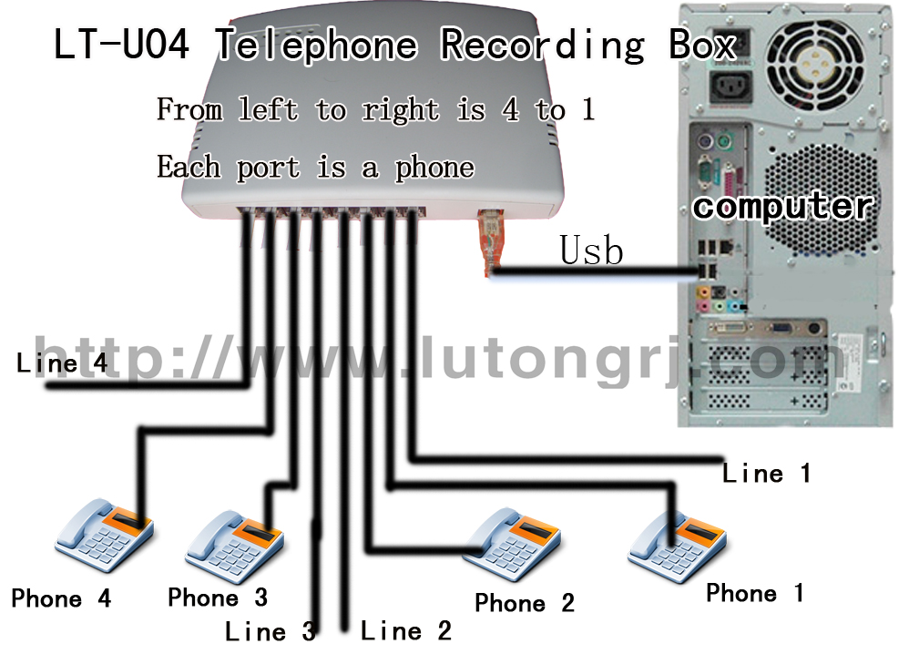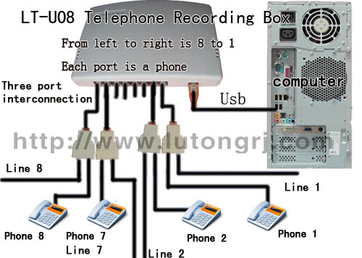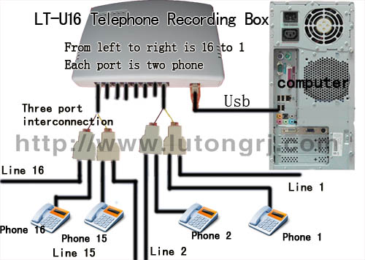

Installation instructions for Software

Caution
Before installation, please make sure the PC is well grounded for avoiding problems of recorder. Method for testing well grounded or not: after chassis connect to ground, please testing the voltage of chassis. If the voltage is less than 1V, we define that it’s well grounded. If the voltage is larger than 1V, it’s the weak grounding.

Installation instructions for LT-P 04/ 08/ 16
- Please copy CD content into a drive.
- Power off PC, open the chassis, insert PCI8 recording card into PCI port.
- Turn on the power, after entering operation system, there is a 【install new hardware wizard, Click【 Cancel 】. Point the pathway to the driver folder in CD-ROM, for example “F: \ LtPciDrive.exe”. click ok, the driver can be successfully installed.
- Right click 【my computer】, choose 【property】->【device】->【device manager】, if there is a device named “Lutong Phone Recorder Card” with driver named “Lutong Phone Recorder Card”. that means your recording card was successfully installed. (one recording card should map one driver). If not, you should do the right steps above again till the hardware can be identified by computer.
- Run “PhoneKeeperSetup.exe” in folder. Just click “next”, then You can finish the setup. You will see the Icon of recording system in the desktop. The software is installed.
- If you want the phonekeeper.exe run automatically every time you start your PC. Please choose 【AutoRestart】from【system】->【Switch】.
- In some case the program will automatically exit during recording when using recording system, you will have to disable the “Hyper-Threading Technology” in BIOS before it can be used properly. The method is as follows: Turn on your PC, press "Delete" immediately and enter "BIOS setup", set “Hyper-Threading Technology” to be “Disabled” in “Advanced BIOS Features”(or other location depends on your main board). If you still have problem to use, and your CPU is Duo Core, change the setting as follows: in “Window XP”, click “start”, point to “run”, key in “msconfig”, point to “BOOT.INI”, point to “Advanced options”, make a mark on the “NUMPROC” and select “1”, then click “OK”. Restart the PC, your phone recorder will work normally.

Installation instructions for LT-U 01/ 02/ 04/ 08/ 16
  - Copy the software in CD to a drive.
  - Turn on the power, connect USB line of the USB recording box into USB port.
  - There is two method of install Drive.
One :after connect correctly, there is a 【install new hardware wizard】, Click【 Cancel 】close it. Point the pathway to the driver folder in CD-ROM, for example “F: \ LtUsbDrive.exe”. click ok, the driver can be successfully installed.
Two: after entering operation system, there is a 【install new hardware wizard】. Click 【next】, then choose 【Install the software automatically (Recommended)】, Click 【next】.Point the pathway to the driver folder in CD-ROM. click 【OK】, the driver is installed.
  - Right click 【my computer】, choose 【property】->【hardware】 ->【device manager】. if there is a device named “Lutong Phone Recorder box” with driver named “Lutong Phone Recorder box”. that means your recording card was successfully installed, as below,
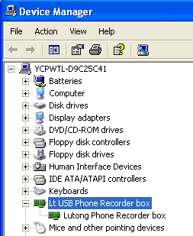
that means driver of LT-U01/02/04/08/16 is installed successfully.
If not, you should do the right steps above again till the hardware can be identified by computer.
  - Run “PhoneKeeperSetup.exe” in folder. Just click “next”, then You can finish the setup. You will see the Icon of recording system in the desktop. The software is installed.
  - For on/off hook errors or recording errors which caused by voltage, and line in/out number display problems. Please inquiry with dealer for paramount changes of 【CARD_CFG.TXT】 in server. Please do not change the paramount by yourself.

Installation instructions for LT-101/102(old)
      - Copy the CD to a drive
      - Please make sure there is no other USB audio device. Right click 【my computer】->【properties】->【hardware】->【device manager】->【sound video and game controllers】. If there is other USB Audio device except, please stop or delete it.
      - For checking driver is installed properly after connecting the USB device with the PC. See the 【sound video and game controllers】 as above if there is a 【USB Audio device】 that means the driver is installed properly. And there is no need to do the e) and f) steps below. If there is no 【USB Audio device】 that means driver installing failed.
      - Run Driver\ SetupFit.exe, if it shows 【Setup is success】. Click 【OK】. If there is a 【Install service failed】. Please Run Driver/UnSetupFit.exe, and it shows 【UnSetup is alraeady】.Click 【OK】. Restart the computer, and Redo the steps above till there is a 【Setup is success】after run SetupFit.exe.
      - Setting: Click 【control panel】->【sounds, speech and audio devices】->【sounds and audio devices properties】->【audio】, select the original sound card in 【sound playback】and 【sound recording】 , other wise, there is a problem about playing audio.
      - Run Phonekeeper.exe in folder. You can see the recording interface. The software installation is finish.

Name of the software
- 【Driver】is the driver of recorder.
- 【PhoneKeeperGreen】is the software. After run【PhoneKeeper.exe】, you can see the recording system interface.
- 【PhoneKeeperSetup.exe】is the software’s package. After run the package, you can see the install interface.

Software Language and network setting

Modify the Language text
After software installation is completed, you can modify the text according to your preference.
- There are 【PhoneKeeper.eng】【PhoneKeeper.chs】and so on. in 【Languages】folders. They were simplified Chinese, English language files. Editing the【*.chs】you can change the simplified Chinese on recording interface. Similarly【*.eng】is for English interface. And you can modify the original language into other language. For example you can replace the English words with related Spanish French etc.

Operating instructions of service software

Recording System startup
Two startup methods:
- Automatically run after entering operation system.
- Left double click the icon on the desktop. There will be a interface as showed in figure 4-1-1 of the recording software.
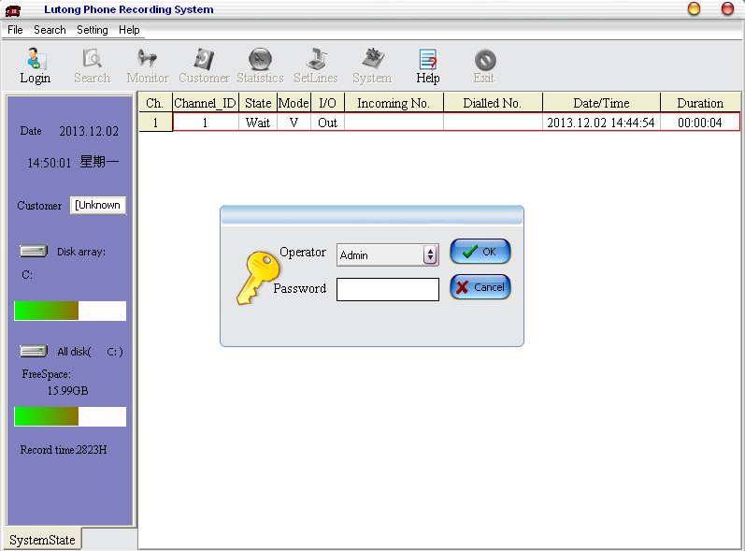
4-1-1
Note：
  - Only user with “Exit” right can exit and close the recording system.
  - Default recording drive is D drive, if none drive is selected, the 【current disk】would be highlighted by red.

User logon
Click 【login】 shows as figure 4-2-1.
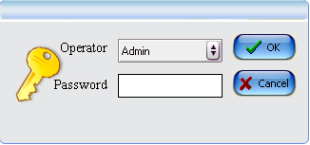
4-2-1
Choose the right username and password, then click 【ok】. If the password is incorrect, there would be a reminding of re-enter the password, unstill the password match with the username. After logon in, recording system shows as figure 4-2-2.
Note: (The system defaults: “Username” is “Admin” and the “password” is blank.)
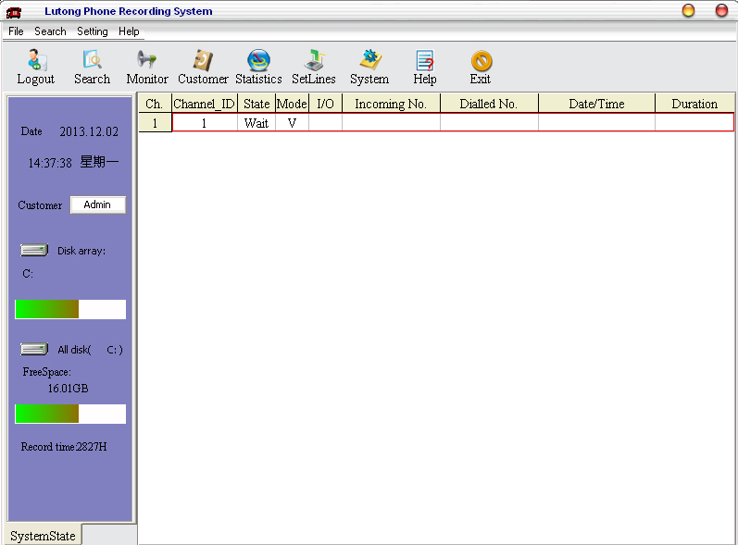
4-2-2

Recording documents searching
After logon in the main interface, click 【search】, you can see the replay interface, choose related searching information, click 【Search】, it shows the history recording documents as figure 4-3-1.
Recording files name format are as follow. For example “C:/TelRecData/20100818/1/20100818-092148-6-I-000025-N-10010-P-S.Wav” , means recording file saved in C drive TelRecData folder, “20100818” is the call date(yyyy-mm-dd) folder. “1” is the recording channel number folder.
“20100818-” the call date(yyyy-mm-dd) , “092148-”is the time of recorded call (hh-mm-ss). “6-”is the recording channel number. “I- “is the out or in, “O” stands for dialing out call. “I” stands for incoming call. “000025-” is the duration time. “N-“is spare parts. “10010-” is the recorded telephone number. “P-S “is also spare parts too. “.Dat” or “.wav” is the recording file format. The recording files can searched in 4 ways followed.
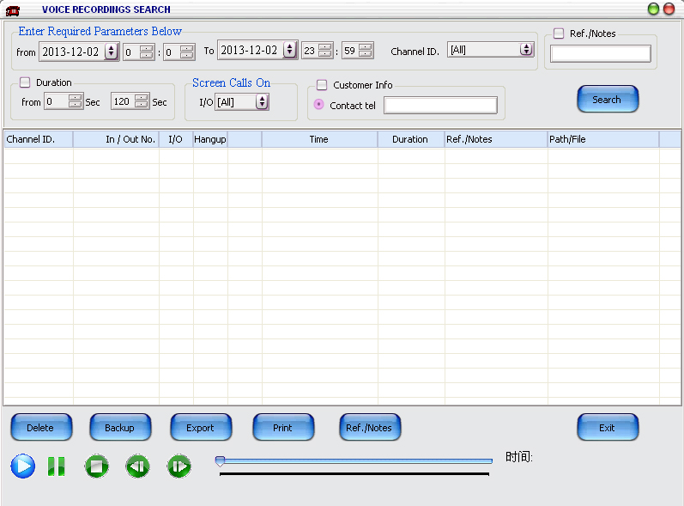
4-3-1
Related information for loading data:

Date and Channel ID.
Date: recording date period you want to search, choose the year, month, day of starting and ending period. Default date is the day you searching.
Channel ID.: Choose the telephone number or line number on which you want to search. It shows the recording documents in searching date of the number. Default line is 【all】, that means all local telephone lines.

Screen calls on
there are three modes in this part: “All”, “line out “and “line in” and “Unanswered”.
“I/O”: 【all】means both dialing out call and incoming call;
【line in】means incoming call;【line out】means dialing out call;
“Unanswered” means no answered call.
“Ref./Notes” means the note what you has marked.

Customer info (support fuzzy query)
Can do searching based on【phone】.
phone】: Recording history which have similar telephone number with the key words will be showed.

Call duration
The software shows the recording history by selecting call duration. Please pay attention that call duration here count from the time you pick up your telephone.

Recording file playing
After loading recording data on dialog box, there will be a recording file list. Click button (play)  (pause)  (stop) (forward) (backward) below for sound card playing the recording file. You can play recording files by plug speaker into audio output of recorder.
⑴ Recording history file sorting
After loading recording history files, it is automatically sorting by telephone number. You can also sort as your preference. Sort method is: click the column title object, the recording system can sort depend on what’s you clicked. For instance, if you click title object【time】,the loaded history files are sorted by call duration order. The first file has the minimum duration time.
⑵ Play, pause, stop (recorder playing do not have pause function)
Select a recording file, click play button and plug speaker into audio output of sound card or recorder. And you can also see the playing progress. Dragging progress bar can change the playing time. Click pause once, the playing pause, click pause again, the playing continues. Click stop for stop playing.

Backup recording history
Select recording files you want to export, click 【Backup】, you can see the dialog box as figure 4-3-2, choose keep path. Click OK.
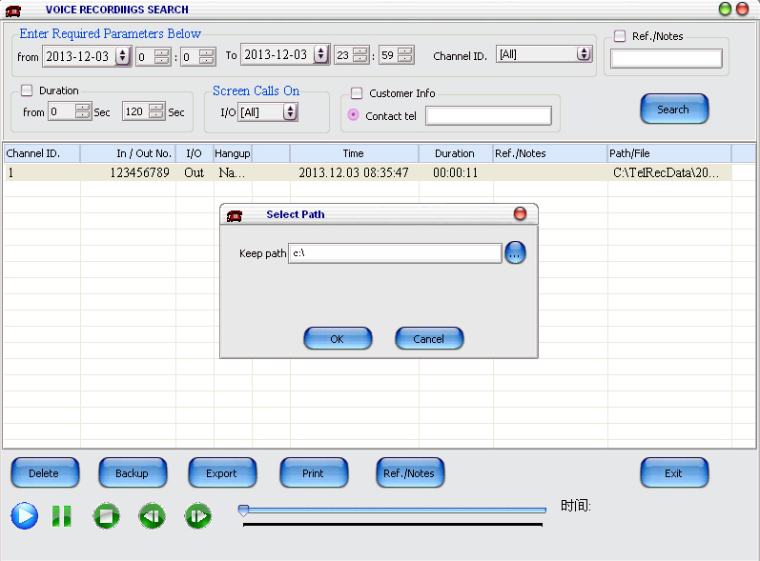
4-3-2
(1) The WAV format can be played by Media Player or sound recorder in windows. The path is “start→all programs→accessories→entertainment→sound recorder”
(2) Export files naming rules:
Export files naming rules is same as the recording files name. The following is “date-time-channel-line in/out-duration time-future unit- telephone number-future unit-future unit .wav”. as shown in figure 4-3-3;( line in/out: o means line out, I means line in)
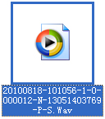
4-3-3

Delete recording history files
Select the recording files you want delete. Click 【delete】button. You can see the dialog box below in 4-3-4, click 【yes】. The selected files are deleted.
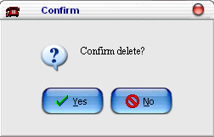
4-3-4

History list to excel file
Click 【Export】can export history list into excel file. Make the list easy to save.
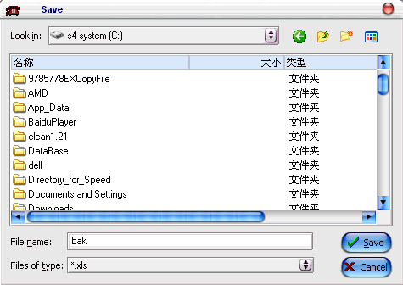
4-3-5

Print out details
For recording history files printing just click 【print】, and then you can see the dialog box below. As shown in figure 4-3-6
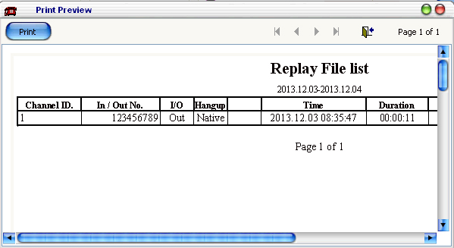
4-3-6
Click preview area can zoom in or zoom out. For files with many print pages, you can use to locate the print page. is used for cancel printing. Click 【print】button then just choose the start and end printing page. As shown in 4-3-7.
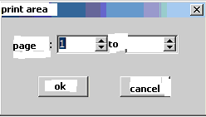
4-3-7
If printing size exceed paper size, you can use mouse change the width and long, till adjusted.

Add note
Selected a recording history file, click 【Ref./Notes】, it shows the dialog in 4-3-8, you can input any comment less than 40 English chars in text box.
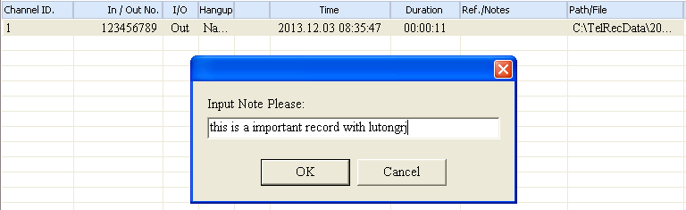
4-3-8

Auto play
On the right bottom edge, there is a 【auto play】, tick the box, the recording history files will be automatically played from the first to the end. If the box is not ticked, only manual play controlling is allowed.

Real time monitoring
If you just need phone recording, you need not click it. The phone recording is automatic. The monitor can play the talk through the Pc sound card; it has nothing to do with recording.
Only user after logon on can have the right of real time monitoring. Click 【monitor】, then the mouse turns into . Click any channel you want to monitor, and then you can hear real time calls of this channel. You can shift real time monitor channel by click the other channel. There are two ways for stopping real time monitoring: one is click the 【monitor】 again. Two is right click in telephone status information region. After stopping monitor, the 【monitor】button will turn into the original status.
Caution: monitoring is available when call is making. Otherwise, there is only noise. Real time monitoring have no influence to the quality of call.
【Monitor】on the toolbar shows the monitor button. Choice one channel and click 【monitor】, then you can listen the talk from PC speaker. The interface shows as 4-4-1.
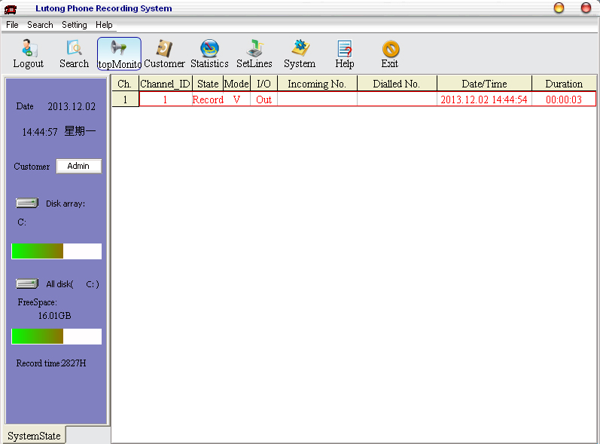
4-4-1

【Statistics】
Click【Statistics】in the main interface shown as figure4-8-1
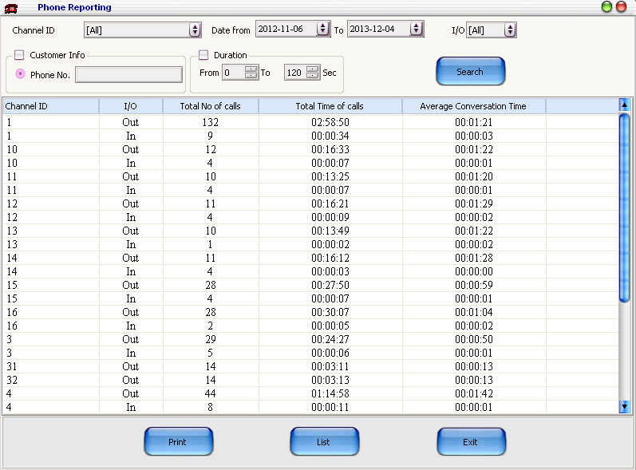
4-5-1

【Statistic analyze】
It’s the statistic of recording history, it can combine the statistic condition of 【Channel ID】【Date】【I/O】【caller information】【duration time】 for searching. 【Channel ID】: You can know calls list of any channel.【Date】: You can see calls list in a specific period of time. After setting the condition combination, click 【Search】, the recording system shows the statistic list. In the list there are 【Channel ID】【I/O】【total calls】【total time】【Average time】information.

【Statistic Print】
【Print】:After searching related statistic data, Click 【Print】, it shows preview interface of printing. Click【List】it export statistic file by EXCEL.

System setting
Only current user with right of【system】can do the system setting. Click 【system】button on the main interface. A system setting interface is popped up. There are 8 sheets:【Record Hard Disk】【User Setting】【Popup】【Record Backup】【Email backup】【FTP backup】【Others】【Switch】

Record Hard Disk
Click 【system】on the main interface. You can see the select recording location page. As figure 4-6-1.
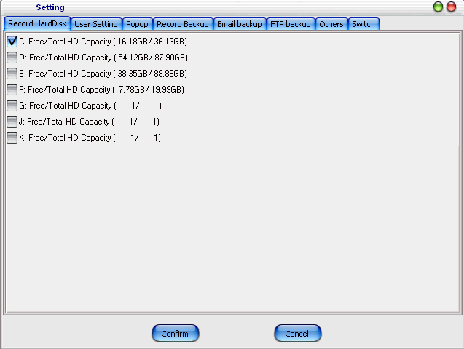
4-6-1
User can select recording storage drive, such as logical drive, network image drive, etc. users don’t need to select all drives. The selection can depend on storage space and recording time. 1G space can storage 175 hour recording files.(5.71M per hour). No call, No recording file, and No cost of hard disk space. For instance: suppose, user need storage recording file for whole year, and there are 8 lines in total, average 1 hour recording files per line. So, the total space for recording is: 365×8×1×5.71M/h＝16673M. selecting 17G space for recording is enough.
Caution:
(1) at least one location for recording files storage should be selected. If no location was selected, recording is unavailable for all channels.
(2) if free or total space is -1. that means the hard disk can not be read. This may be caused by damaged disk, wrong format, etc.
Recording files are saved in “TelRecData” folder under root disk.

User Setting
Right of user can be set as figure 4-6-2
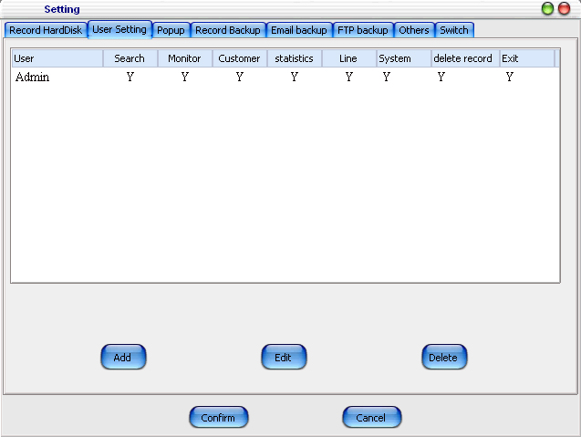
4-6-2
Click 【Add】it shows figure 4-6-2-1, enter a new username, for example, a new user named【test】. Then tick permitted rights of the 【test】. If you need set a new password, just tick 【modify password】enter the old password and new password. Default password is null and default user is 【admin】.
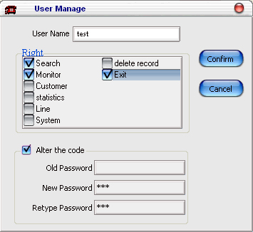
4-6-2-1
For modifying the rights and password of user, click 【modify】or double click the username. There is a dialog box as figure 4-6-2-2. Modifying username is prohibited.
4-6-2-2
Caution:
(1) Before modifying password. You should enter your old password for security consideration.
(2)”admin” account can’t be modified, because the “admin” have all rights. Any modification of “admin” is invalid. It’s automatically default setting after system restart.
(3) Delete user: select user, then click 【delete】, a dialog box will pop up, and make sure you want delete it. Click 【OK】, the user is invalid.
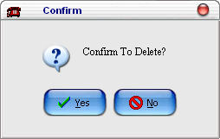
4-6-2-3

Popup
Popup setting is for setting pop up function. On the PC with server and logon on client can automatically pop up related information of incoming calls. Setting interface is shown as 4-6-3. There are 【User’s Name】【Monitor Play】【Caller ID call Popup】
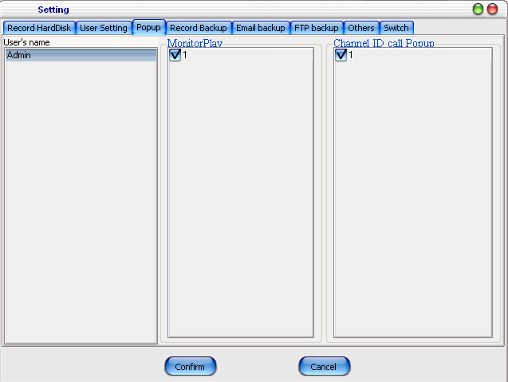
4-6-3
⑴【User Name】shows all users they are the same with users in【User】. it is the user name in "user setting" interface. As the user name in "user setting" is changed, the user name in the incoming call popup setting changes. When the client log in, the local number that pops up due to incoming call and the restriction of caller ID number can be set here.
⑵【Monitor Play setting】shows the channel number which can be see by a specific user. You can choice the authorized channel number in 【Monitor Play】setting. Take figure 4-6-3 as an instance, after click a user named 【admin】, then you can choice number 1 in the Monitor play setting. So, the 【admin】can monitor and see the recording information of channel 1.
it is used to control if the user can monitor or inquire the recordings of given channels. Only the recordings of the selected phone lines could be monitored and played. While others are not available.
⑶【Caller ID call Popup】is the setting of 【Client Popup】software. It shows name or number of all channels. After selecting a user, tick the channel number or name which can be monitored by the user through 【Client Popup】software. Take figure 4-6-3 as a instance, the 【admin】can monitor all channels through the 【Client Popup】software.
for specific users, they can choose to pop up one or more local phone call. Besides, a local phone can be set to pop up in many login client-sides. For instance, users want to learn about the incoming call situation of some phone lines in time, they only need to tick the check box before the telephone. When any one or several of the telephone lines have incoming calls, the information of the incoming call will pop up automatically.

Record Backup
Click “Record backup” will shows as figure 4-6-4
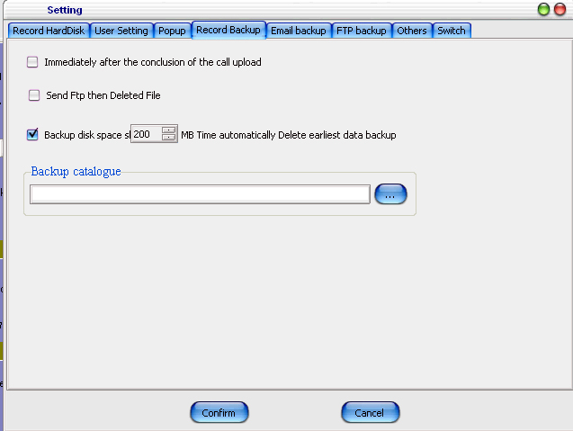
4-6-4
(1) 【Immediately after the conclusion of the call upload】：if users adopt this option, the recording file will be automatically uploaded to the pre-set FTP server;
(2) 【send FTP then delete file】：if users adopt this option, the local recording file will be deleted after the file has been uploaded to FTP server and no recording file will be saved in local computer.
(3) 【Backup disk space short ** MB Time automatically Delete earliest data backup】：if users select this option, when the disk space is less than the pre-set value, the system will delete the previous records automatically.
(4) 【Backup Catalogue】：when recording is finished, the system will copy the recording file to this given directory.
Note: in general, it is not necessary to activate the backup function, because the system does automatically cycle recording.

Email Backup
Email Backup Make backups by mailing. Click “Email backup” will shows as figure 4-6-5
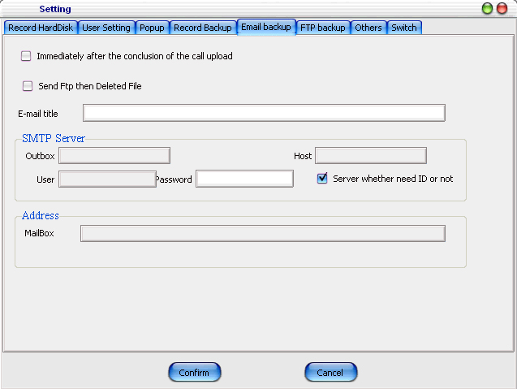
4-6-5
it is to send the just-ended recording file to the given mail box, so that the user can listen to the file from far away. If you have an email, you can send the recording file to your email box right after the end of each recording, so that you can listen to the file when you are away. Please contact the service provider for details of the SMTP server address.
When using email forward service, you should provide two emails, one for sending and the other for receiving.
(1) 【Immediately after the conclusion of the call upload】：if users take this option, the recording file will be automatically uploaded to the pre-set FTP server;
(2) 【send FTP then delete file】：if users take this option, the local recording file will be deleted after the file has been uploaded to FTP server and no recording file will be saved in local computer.
(3) 【E-mail title】：the title of the email.
(4) 【SMTP Server】:
【Outbox】：for sending recording files.
【Host】：the SMTP of the mail box which is used to send recording files. Please contact service provider for details. Somewhere the host do not allow soft send the email.
【user】：the login user of the outbox.
【password】：the password of the outbox.
(5) 【Address】: email box to receive recording files.

FTP Backup
Click “Daily backup” will shows as figure 4-6-6
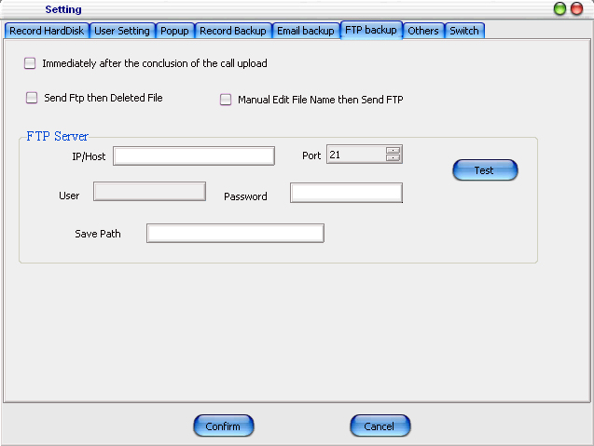
4-6-6
If you have a website, you can transmit the recording file to an assigned FTP server, so that you can listen to the recording file. Compared with sending to email box, it has several advantages: high capacity, fast uploading speed, convenient management and so on.
fill in the FTP server address, user, password, and save path; and then click "test" button to check if the setting is correct. Please consult service provider or network administrator for details of FTP server address.
(1)【Immediately after the conclusion of the call upload】：if users select this option, the recording file will be automatically uploaded to the pre-set FTP server;
(2)【send FTP then delete file】：if users select this option, the local recording file will be deleted after the file has been uploaded to FTP server and no recording file will be saved in local computer.
(3)【FTP address or domain】: name of main machine. It is better to fill in the IP address of FTP computer; domain is acceptable as well when it is not a LAN.
【port】：The default value is 21. Do not change it easily.
【User】：Log in FTP user name.
【password】： Log in FTP password.
【Save Path】：A folder to be set up in FTP or a target folder where the recording is to be sent.

Other parameters
Click 【others】, it shows as 4-6-7.
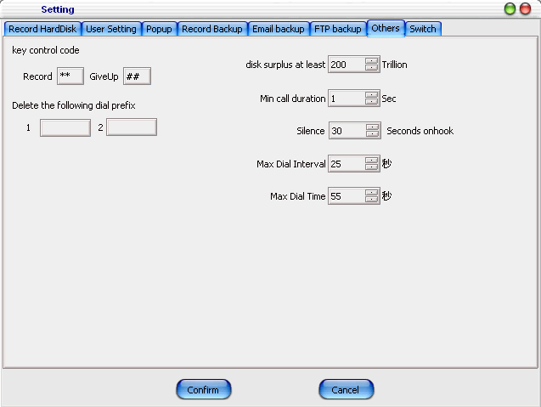
4-6-7
【key control code】：This option controls recording starting and abandoning.
【Delete the following dial prefix】: the pre-set extra number before dialing number will be automatically deleted if there is any.
【disk surplus at least ** Trillion】：it is used to control the residual space of the disk. The size of residual space should be decided according to the recording disk or disks. In case that more than one disks are available, the system will shift to the next disk when the residual space of the current disk is less than pre-set value.
【Min Effective Conversation ** Sec】：it refers to a minimum conversation time period, starting from picking up the phone, for a valid outgoing call, otherwise, the call will be treated as invalid, and no recording will be made. The purpose of this parameter is to reduce the number of invalid recordings. There is no limit to the value range, and the default value is 5 seconds. A outgoing call within 5 seconds will not be recorded.
【Max Dial Interval ** Seconds】：the dial interval should not exceed the pre-set value when making outgoing call. Otherwise, all latter dial will be considered as invalid. The system default value is 25 seconds. For instance, when users dial "12345678", he/she dials "123456" first and "78" 25 seconds later. Then, "78" could not be recognized as dial numbers, only "123456" is recognized as dial number.
【Silence ** Second As onhook】：this is only for voice-activated recording channel. When silence longer than the pre-set seconds is detected, the conversation is considered to be over. The system default value is 30 seconds. The silence hang-up value range is from 1 to 30 seconds.

Switch
Click 【Switch】, it shows as 4-6-8.
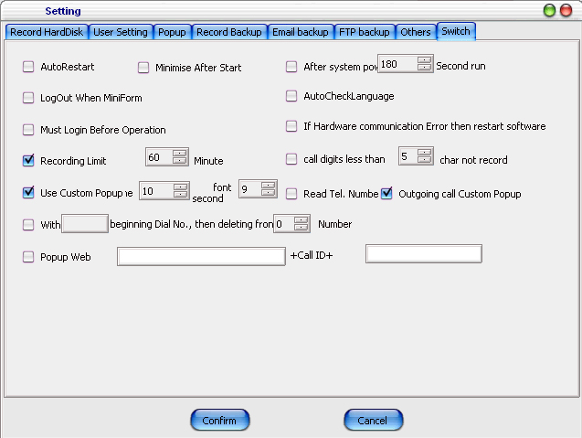
4-6-8
【Start Automatically When System Starts】：If users select this option, the software will start automatically when the system starts. The software will start a few seconds later when the user selects 【after systems popup ** seconds run】.
【Minimize After Start】：when users select this option, the software will automatically minimize to a tray icon in the bottom right corner of windows, when the system starts.
【LogOut When MiniForm】：when users select this option, the current user will log off when minimizing the system.
【LogIn When Minimize Restored】：when users select this option, they have to enter operator and password again after switching from minimize to interface.
【Auto Check Language】：if users select this option, when the program starts, the display language will be the default language of the system. Other language selected according to the list of the interface will be of no effect when the system restarts.
【Use Custom Popup time ** seconds font **】:if users select this option, a customer information window will pop up when there is an in-coming call; the display time of the popup windows is the same as preset. The windows will close when the time is up. Please set 0 second to keep the window always on. The font size of the popup window is controlled by font **. The font should not be too large, as it could lead to incomplete display.
【With ** Beginning No., Then Delete ** Number】 ：if users select this option, the system will delete the pre-set number. This function is normally used for the extension telephone behind switchboard, which requires extra number for calling out.
【Popup Web ** + Call ID + **】：the in-coming call could be automatically opening given webpage, and add the in-coming phone number into the given webpage. For instance, you fill in http://www.lutongrj.com/getcid#+ in-coming number +#.sap. When the phone number 12345678 calls in, the system will open the link http://www.lutongrj.com/getcid#12345678#.sap. The function application will automatically transfer the received number to the self-developed webpage, and it works with users' OA system together.
【If Hardware communication Error then restart soft】：If users select this option, system's self-diagnosis function will be initiated. When the communication between the system and hardware is abnormal, the software will be restarted. The function is suitable for long-term unattended servers. Artificially unplugging of recording box will lead to software repeatedly restart. It's not recommended.
【Recording Don't Exceed ** Minutes】：This option is used to control the recording time. When the recording time exceeds the limit, the system will terminate the recording automatically.
【call num less than ** char not record】:This is used for controlling recording when dialing wrong number. In general, a valid phone number should exceed certain length.
【save DTMF in talking】：if users select this option, the system will record the key numbers during the conversation in the in-coming number. This is suitable for special occasion. It is not a recommended option for regular users.
【Read Call Number】：if users select this option, the system will read the numbers out automatically.

Channel Setting
Click 【SetLines】you can see the 【setting Line interface】. You can set channel properties here. See figure 4-7-1.
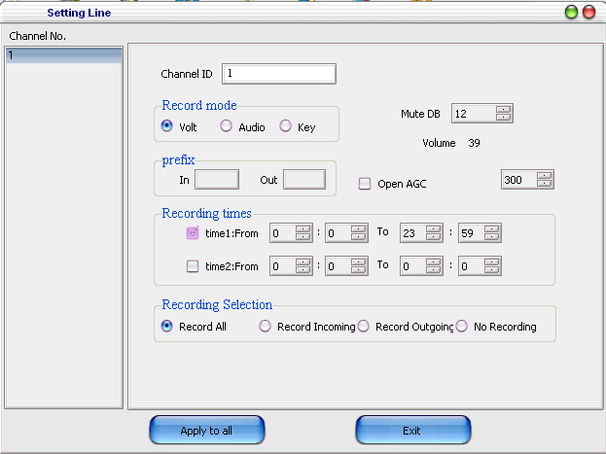
4-7-1
The software can detect how many channels are there. For example, if the recorder is LT-U08, the channel NO. Column shows 8 channels; if there are two LT-U16, it shows 32 channels. Selecting one channel, the right area shows related information about this channel.
1) 【Channel ID】it’s the number of local telephone. This blank should be filled in correctly. If the Line ID is null, the recording system can’t work. The tip: the 【Channel ID】can be someone name, such as smith.
2) 【Recording mode】there are 【Voltage control】【Audio control】and 【Key control】modes. For 【Voltage control】is the default recording mode, it can shows the dialing out and incoming call numbers. For 【Audio control】and 【Key control】modes. It can’t show caller ID both dialing out and incoming. Tick the mode you want for selection.
【Key control】method: pressing 【**】 key means record this call. pressing 【##】 key means do not record this call.
For WAV software, If you need 【Audio Control】. Please do one more step except ticking. Please change the value of 【CARD_CFG.TXT】 in server folder. Set the 【VOICECONTROL=1】(0 is the voltage control)
3) 【Prefix】some telephone numbers have the same prefix. For example, the exchange telephone displays a number 9 before all caller number. So, set 9 as the Prefix number. The recording system can record the correct telephone number without 9 at the first number. The rule is the same of In prefix and out prefix.
4) 【record selection】Four choices, they are 【all】record both incoming and dialing out calls.【In】record incoming call only.【Out】record dialing out call only.【No】do not record.
5) 【Record time】default recording time is whole day. The first record time is a must-select item. You can modify the recording time as you want.
6) 【Mute dB】is the environment sound setting. When it’s the 【Audio Control】the system should know how many dB is the Mute value. So, the higher value, the louder voice is needed for starting the recording system. The best value depends on different recording environment. When it’s the 【Voltage Control】this value should larger than the current noise value(showed on the right of Mute value, changing all the time).otherwise, it cause error on on hook and off hook detecting.
7）【Apply to All】apply the setting of current line to all channels directly. For example: if all channels need the 【Audio Control】mode, just set at one line. Then click 【Apply to all】, so that, all channels use the 【Audio Control】mode.

Customer
Customer management is used to classify and manage customer name card. You can modify and add your name cards or name card groups.
Only the logon on user with right of 【customer】can use this function. Click the button 【customer】 in main interface:
Pop-up interface of “name information management” is shown as 4-8-1.
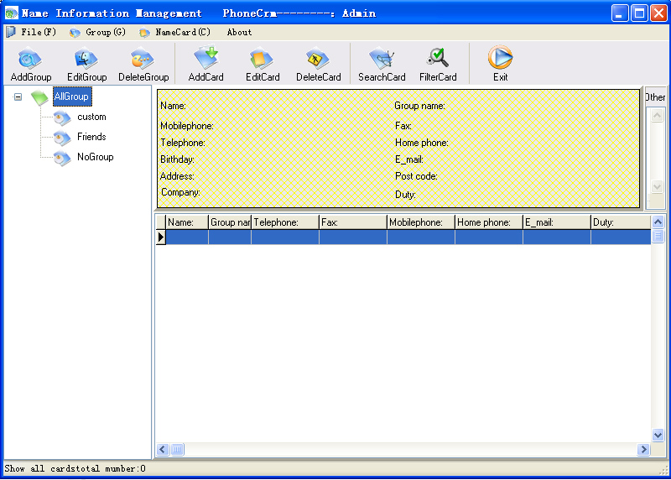
4-8-1

Add/Edit/Delete/Empty Group
[Add Group] add a new card group.
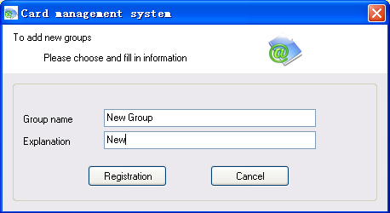
4-8-2
[Edit Group] Edit a group name.
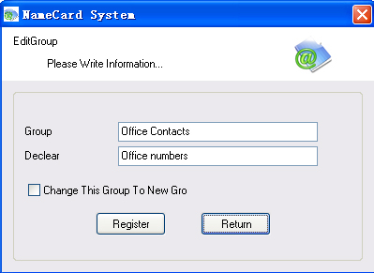
4-8-3
[Delete Group] delete a group, and the custom in the group will change to NoGroup.
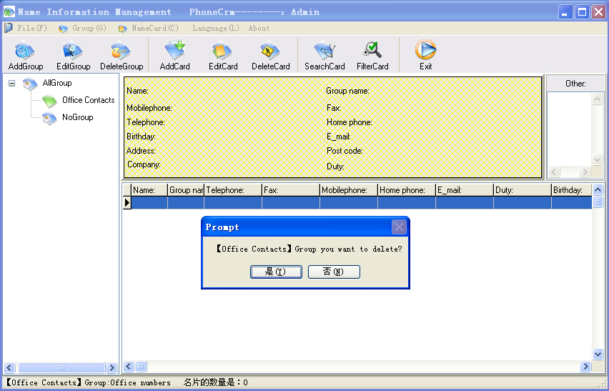
4-8-4
[Empty Group] delete a group and all data in the group, can not restore.
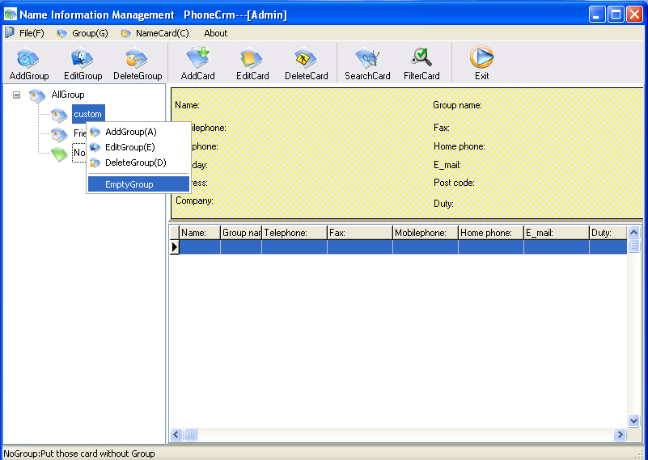

Add/Edit/Delete Card
[Add Card] pop up a blank customer information input interface, please input the information to save.
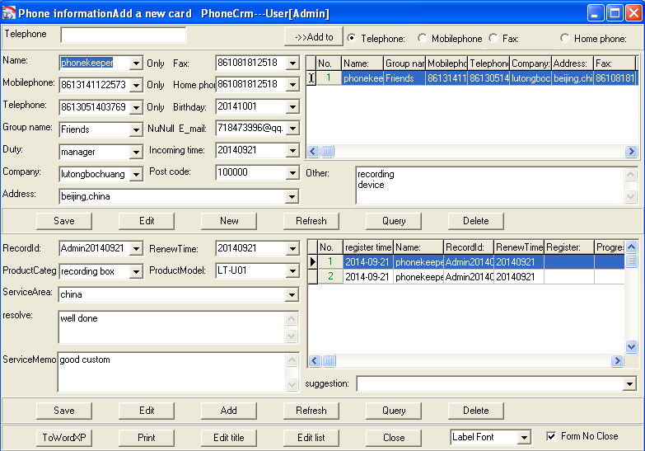
4-8-5

SearchCard
[SearchCard] carry out information search according to assigned fields. It could be either refined search or fuzzy search.
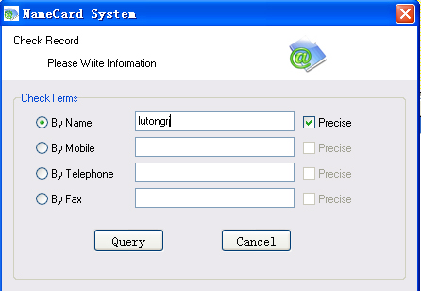
4-8-6
[Filter Card] filter card information according to assigned information.
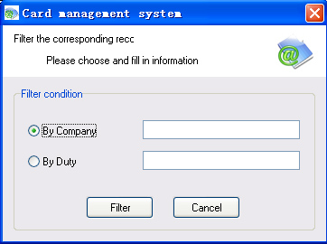
4-8-7

Operating instructions of Screen Popup

Screen Popup Interface
When someone calls in, the system will display the caller's name and other information. There are several ways for displaying caller information: tray prompt, only main interface popup, phone No. broadcast, main interface popup and so on.
Of course, the caller's information has to be stored in the database in advance, or the caller calls again when his/her information has been stored after his/her first call.
You can make some customized settings in "options → other setting" according to your needs, such as, closing time of popup interface, font size of the popup interface and so on!
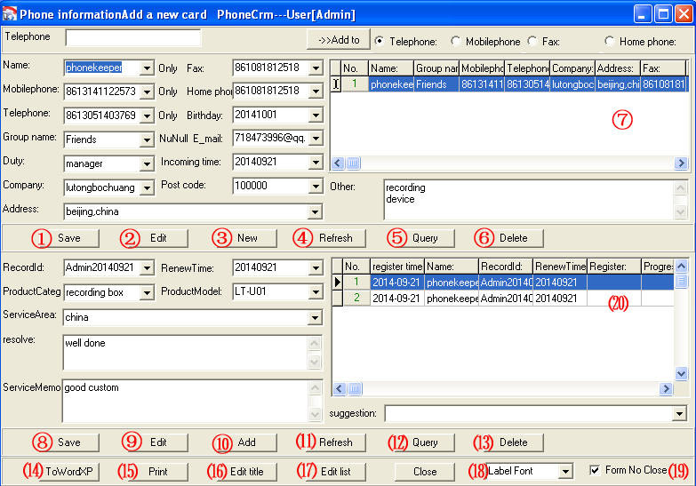
5-1-1
①②③④⑤⑥⑦ deal with the customer information.
After you edit or New a name card , you should click save.
Refresh can clear all name card item, then you can write something for query. If you choice a record in ⑦ , you can click delete to delete this record. If you double click a record in ⑦, the ⒇ will show all this record conversation.
⑧⑨⑩⑾⑿⒀ ⒇ deal with the conversation each time.

⒅is setting of the font in this form. You can choice a size to change.
⒆ control this form auto close, because the form will close after the setting time.

⒁Incoming call ToWordXp
When you click ⒁ ToWordXp, the system will open the template in the folder “Reports\ PrintTemplate.doc” and write the form information to it.
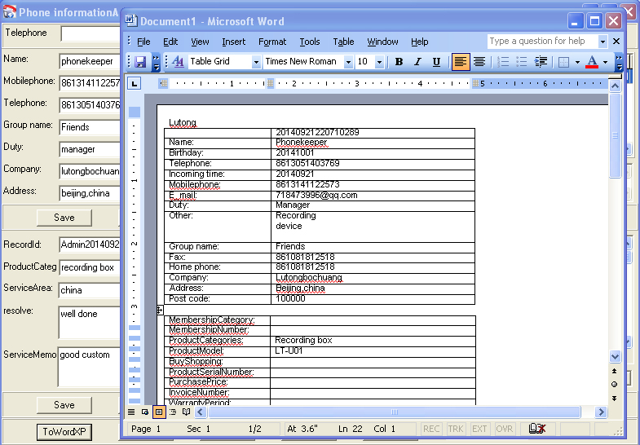
5-2-2

⒂Incoming call print

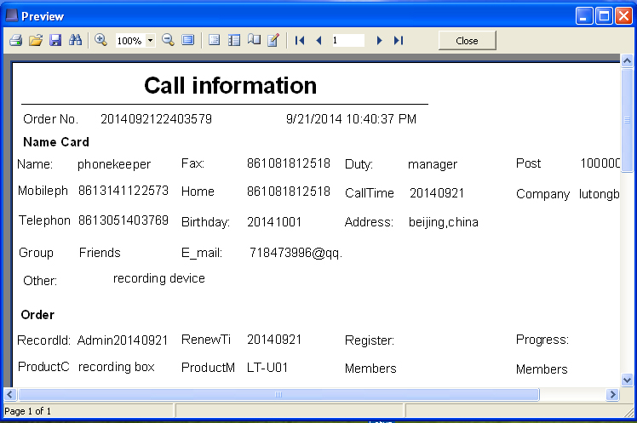
5-2-3

⒃Modification of Popup Interface
Information that pops up when a call comes and each corresponding title of customer information can be changed by means of changing the title here.
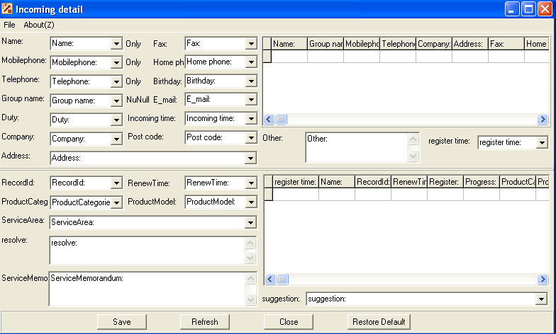
5-3-1
When the above contents are changed, the relevant information of other interfaces will be changed. For instance, when the [name:] is changed into [customer:], all [name] of the two interfaces below will automatically change to [customer:].
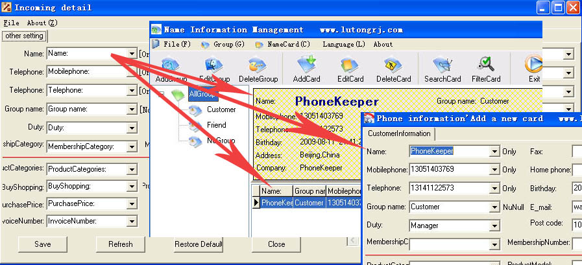
5-3-2

⒄Modification of Drop-down List
The fast input options are used for modification of drop down list of popup interface.
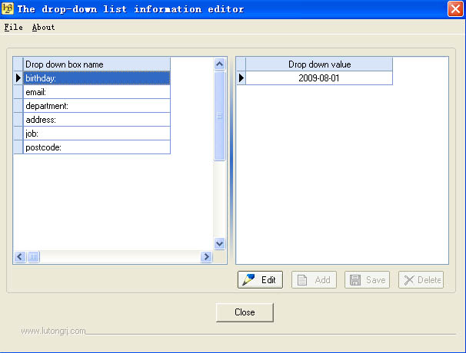
5-4-1
After setting all fields above, it will show the effect in the following figure.
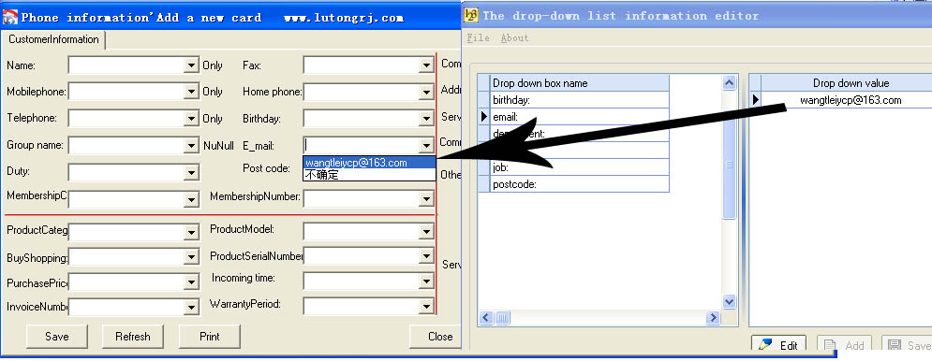
5-4-2

Database Import & Export
It is easy and fast to directly import customer data from Microsoft Outlook，Outlook Express and Excel to system database; and it also can directly import customer data from database to Microsoft Outlook，Outlook Express and Excel.
In order to ensure successful data importation, we suggest exporting a null system record first, then fill the card information according to exported system file, and return to import it into the system at last.

Import of Excel Data
Select the Excel file to be imported; set the range of data (from which row to which row) to be imported; then click to import. Note: the format of the Excel file to be imported should be in line with the system export format.
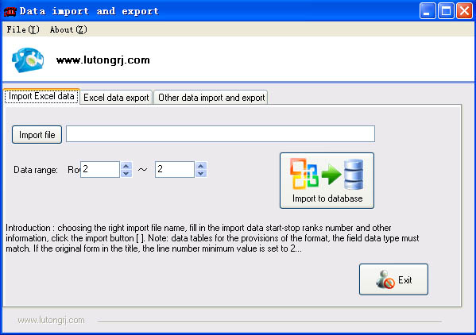
6-1-1

Export of Excel Data
Select the storage path and name of file to be exported; then select the range of data to be exported. All data will be exported when you choose [all]. When choose [Whether the group name to export], the system will export the name cards of the assigned group to Excel.
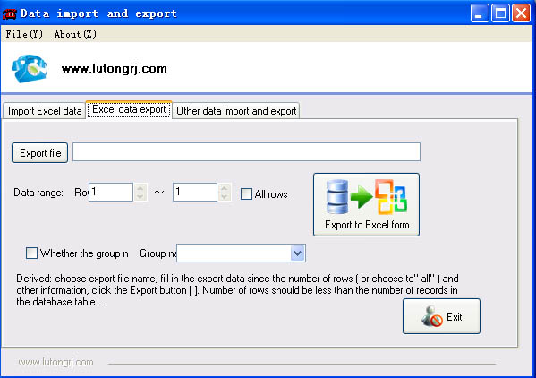
6-2-1

Export & Import of Other Data
Data import: if it requires importing the customers information of Microsoft Outlook，Outlook Express and Excel into Phonekeeper system, the source should be firstly selected and imported from drop down list "Type". Select the path when importing data from Excel, and no path needs selecting when importing data from Microsoft Outlook and Outlook Express. Click "Introduction to system" afterwards.
Data export: if it needs to export the data of Phonekeeper system to Microsoft Outlook，Outlook Express and Excel, a Excel file for Excel should be set up. Select the "Type" and click "The telephone system is derive" afterwards.
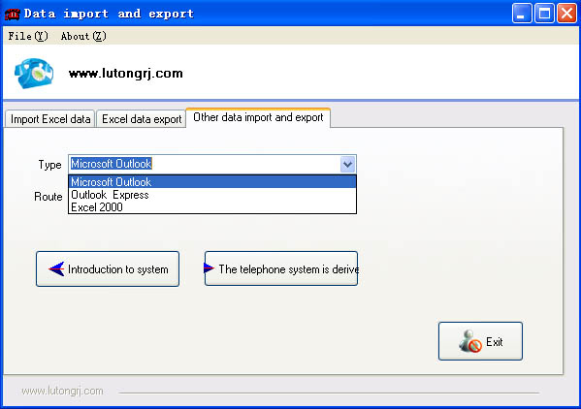
6-3-1

Database Maintenance
A survey to most of the customers shows that some function of this section is unserviceable. So, only compress function is kept. In case you need to use this function, please conduct database compression by starting "databak.exe" in installation directory!
When you conduct some delete operations to a database with mass data, the size of database file will not change. Thus, you need to compress the database, in order to reduce database redundancy, avoid waste of space and increase access speed. Before compressing database, please shut down the system and ensure the database is not being used. The default storage file of system customer data is "Config.dat", which is stored in the installation directory.
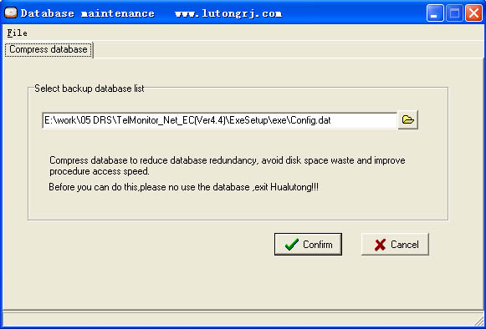
6-4-1

Problem solution
if you windows is sleep, it will cut the power for USB. You should shut up the sleep when use the recording box.

Check PC connect ground solution as follows
1. If the recording system installation .as usual and recording software can work normal, but have problems as follows
⑴. Can’t record
⑵. Record or hook on and hook off unsteadily
⑶. Didn’t show dial out number
⑷. Dialed out number not complete
⑸. Dialed out number was wrong
⑹. Without incoming call number
⑺. Incoming call number not complete
⑻. Incoming call number was wrong
All of these problems came from PC connect ground not very well

Technical Parameters
Input: 1 to 64 channels ,increase by 1 or 16 channels
Interface: analog trunk with two lines
Impedance: high impedance ＞ 8 Mohm
Temperature: +5℃—+40℃
Humidity: 5%—85%
Collection speed: 64Kbit/s per channel, compression ratio is 1, 2 and 4.
Recording time: no limitation
Interface impedance: 600 ohm
Signal-to-noise ratio: 50DB
Frequency response: 300Hz~3400Hz
On-chip cache: 32K~256K Byte
Data rate: 64Kbps、32Kbps、16Kbps
DTFM code: 0~9、*、#、A、B、C、D
Exchange function: direct exchange of 128 channels
call monitoring: signal tone, voice
Calling number: FSK、DTMF
FSK modulation system:
Logic 0: 2200Hz±1%
Logic 1: 1200Hz±1%
Data transfer mode: asynchronous serial of binary system

Contact us

Add：No. 8, South Building 2, Yudu Restaurant, No. 85, Beiwa Road, Haidian District, Beijing City

Zip Code : 100036

Skype:lutongkeji

Email: wangtleiycp@163.com 718473996@qq.com

Q Q : 718473996、773834194

Website: http://www.lutongrj.com

